**User interface Process**

1. **Create Custom Lightning Record Pages:**

Create the patient lightning record pages:

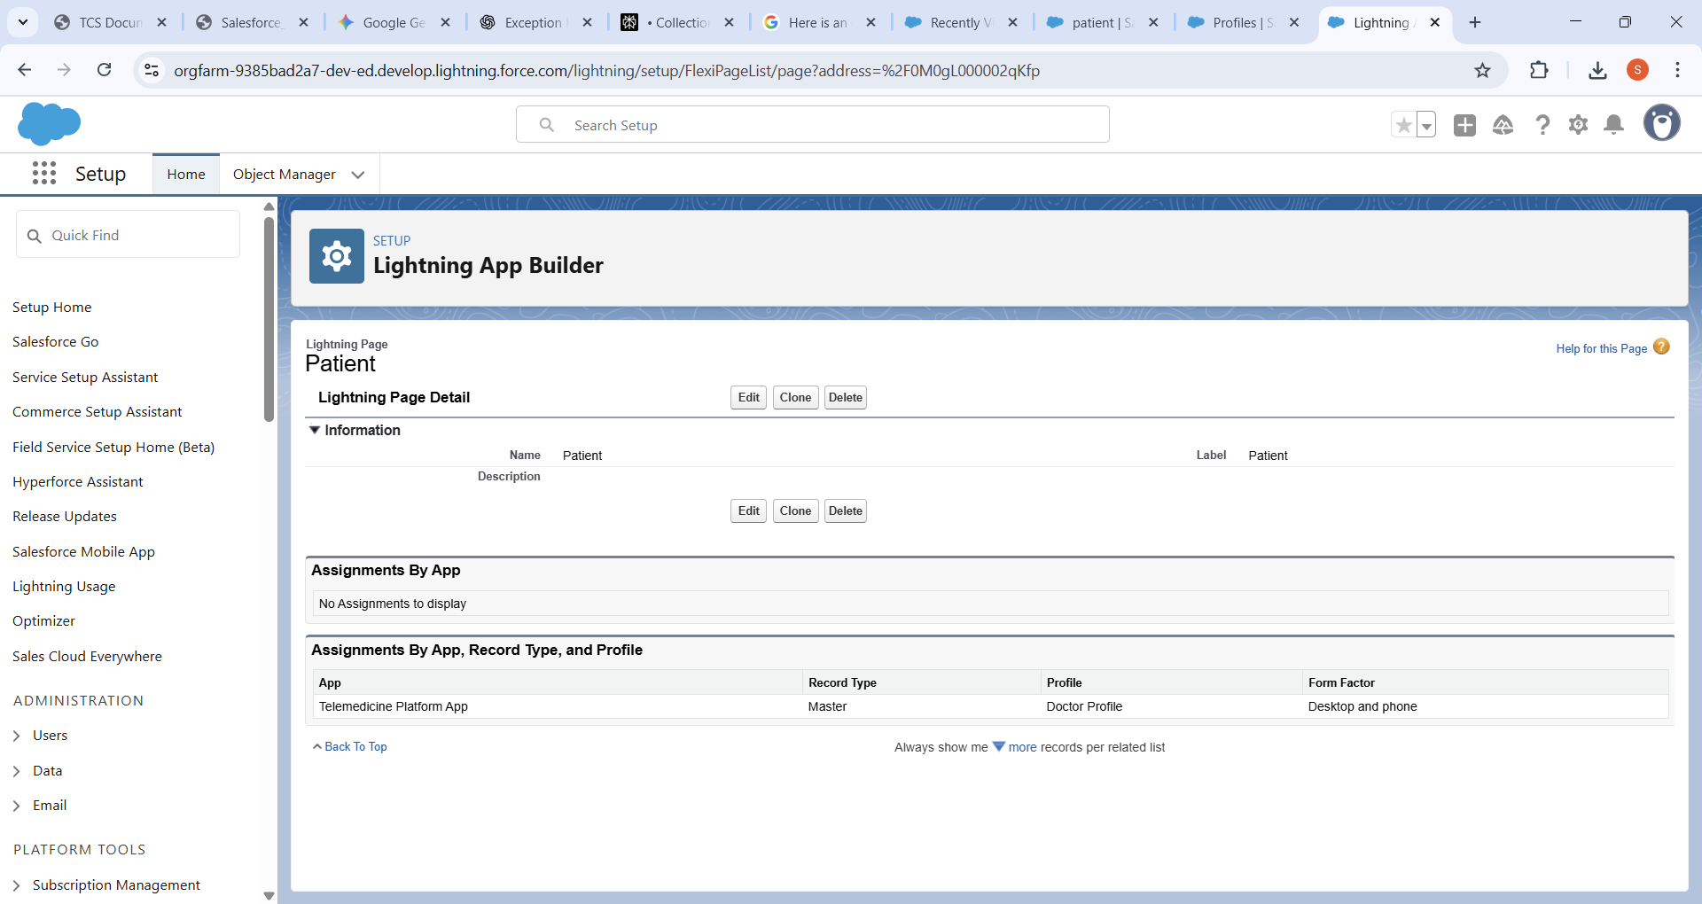

Check at the doctor Profile:

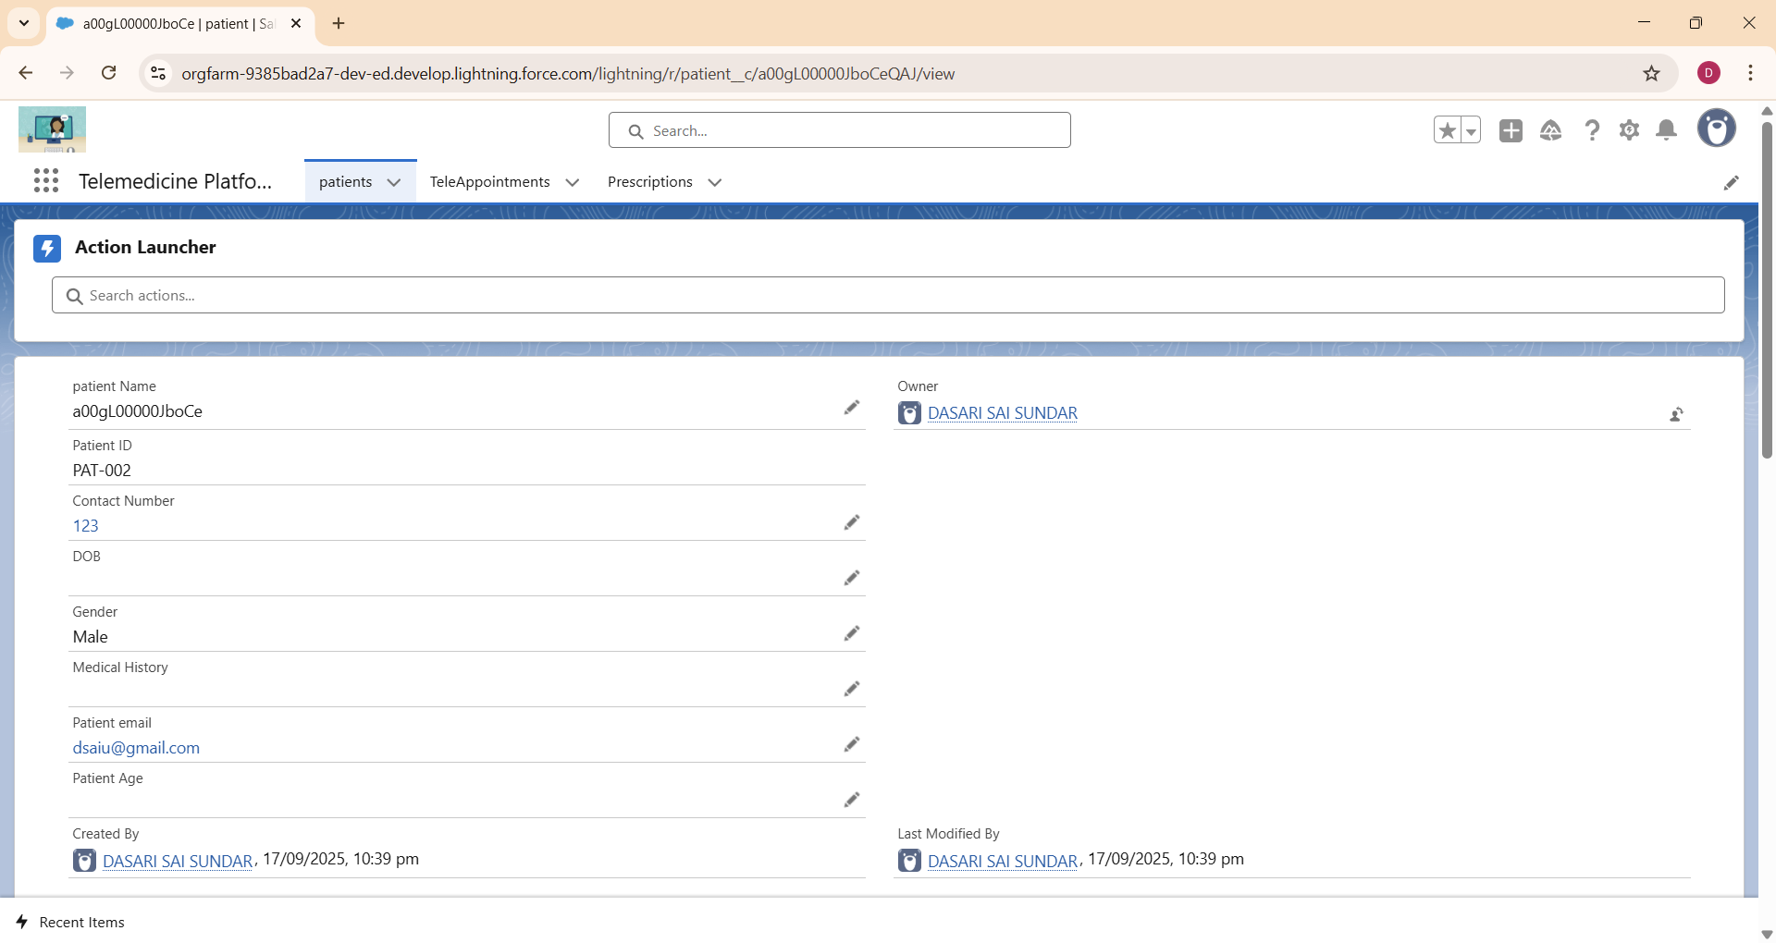

Create the TeleAppointment lightning record pages:

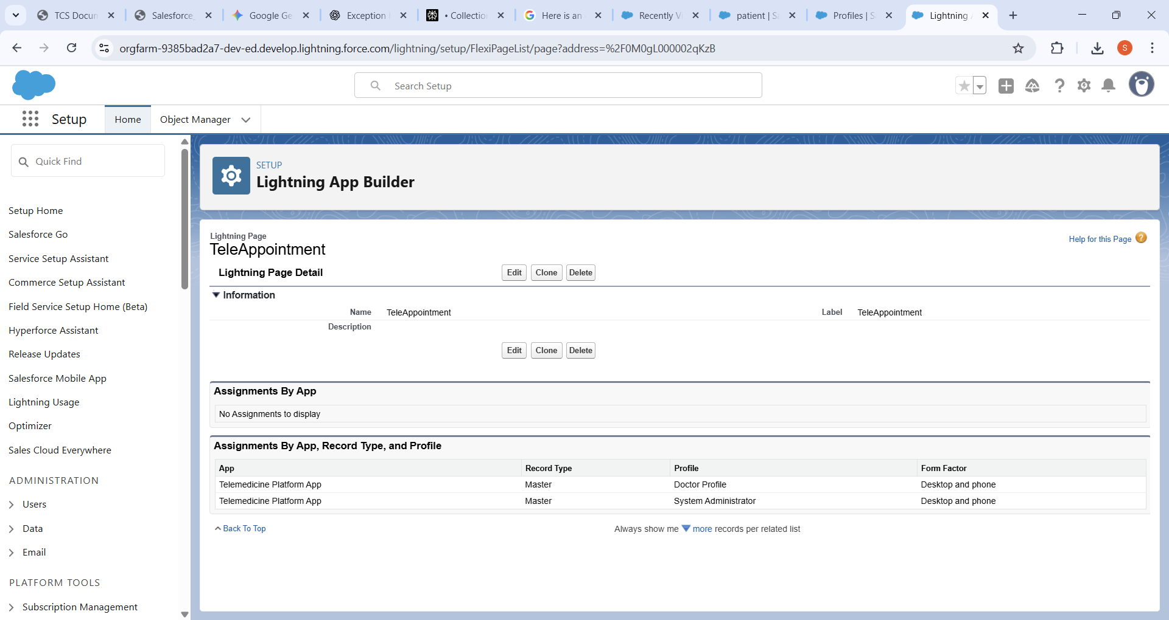

Check at the doctor Profile:

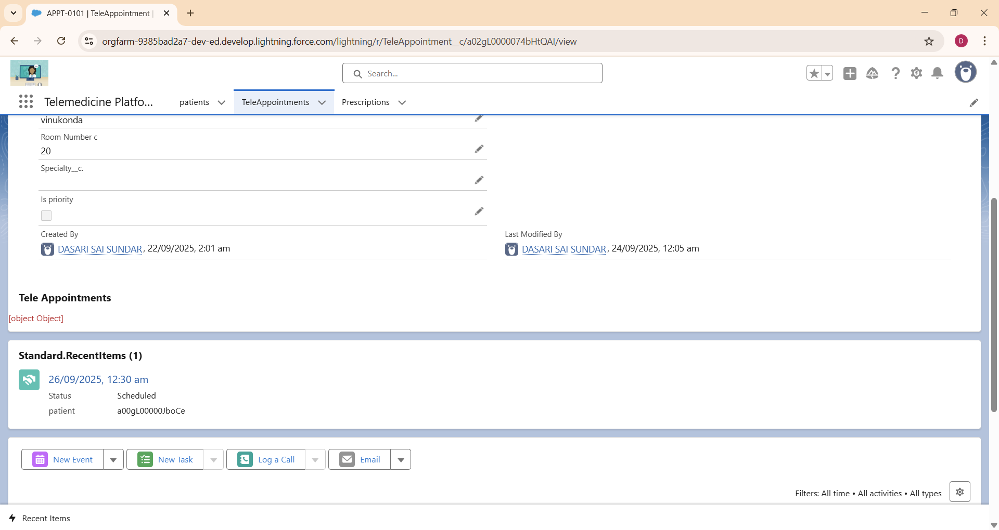

The Patient Lightning Record Page and TeleAppointment Lightning Record Page are customized to display and manage crucial patient and appointment details respectively within the Telemedicine Platform. These pages are assigned to the Doctor Profile to ensure doctors have seamless access to relevant patient information and appointment management tools on both desktop and mobile. This setup enhances the efficiency of medical consultations and telehealth service delivery.

**2.Create Your Lightning App Framework:**

Created The Lightning App:

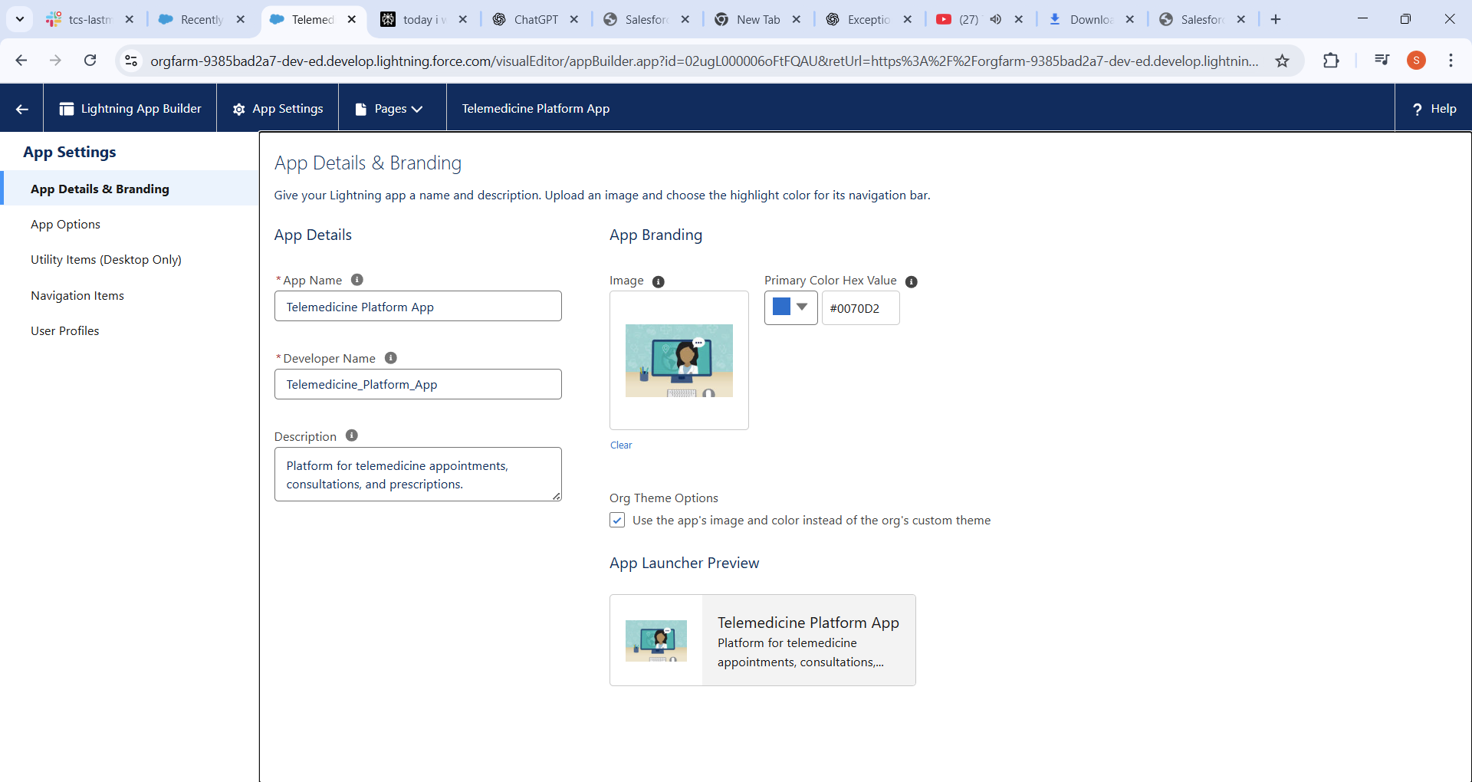

The Navigation Items Selected:

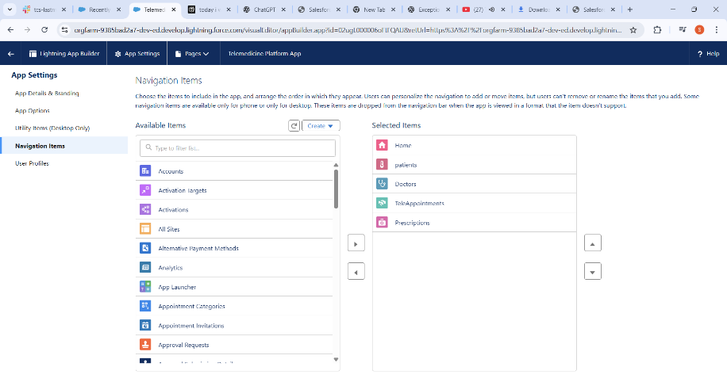

User Profiles Have Selected: As I Have 3 Main Users I have selected Three.

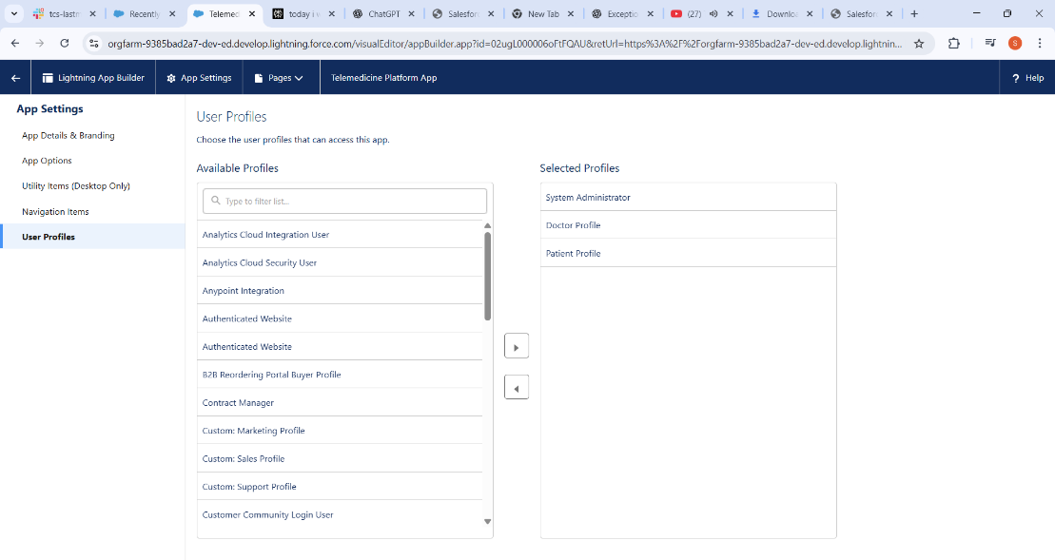

The Lightning App Framework for the Telemedicine Platform App is set up with custom branding, a description, and a highlight color for easy recognition. Key navigation items—Home, Patients, Doctors, TeleAppointments, and Prescriptions—are added to streamline access to core features. Specific profiles such as System Administrator, Doctor Profile, and Patient Profile are granted access, ensuring each user role can interact with the app as required.

**3.** **Tabs:**

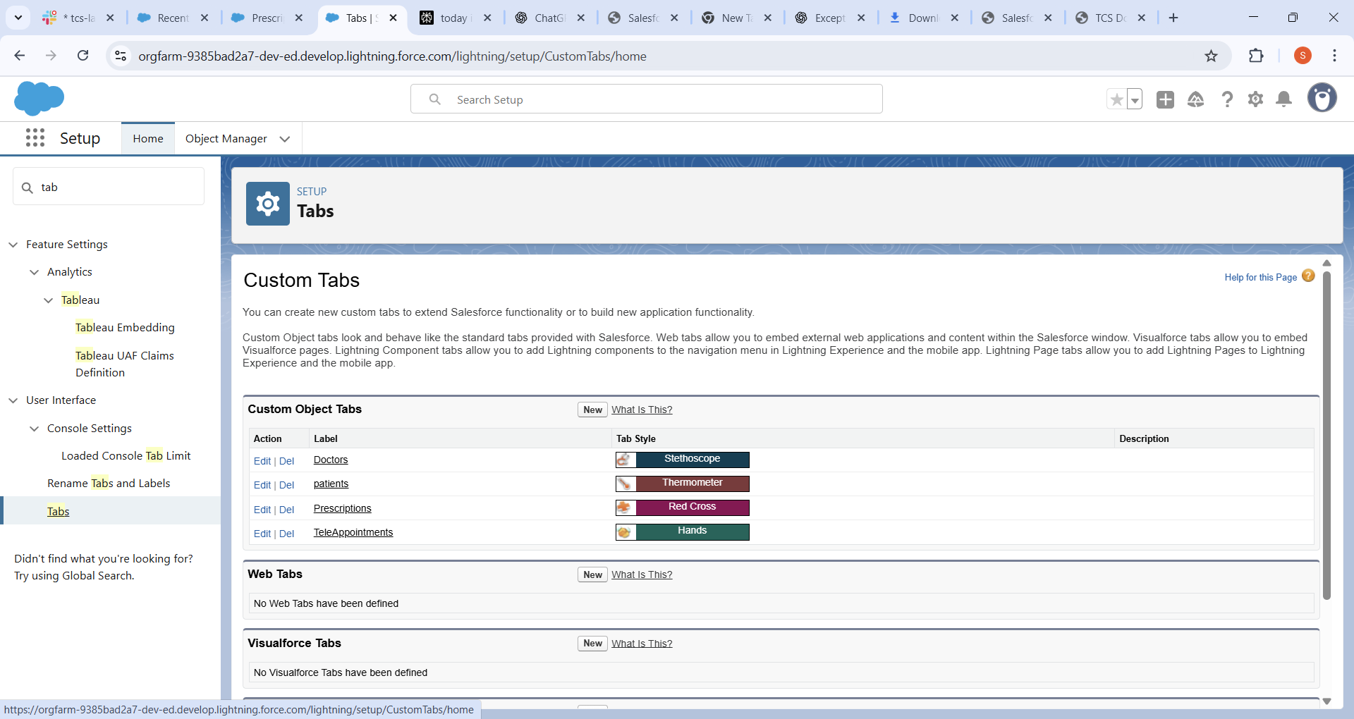

These tabs help users quickly access relevant records and features in the telemedicine platform with distinct icons for better visual identification.

Patient Tab Created:

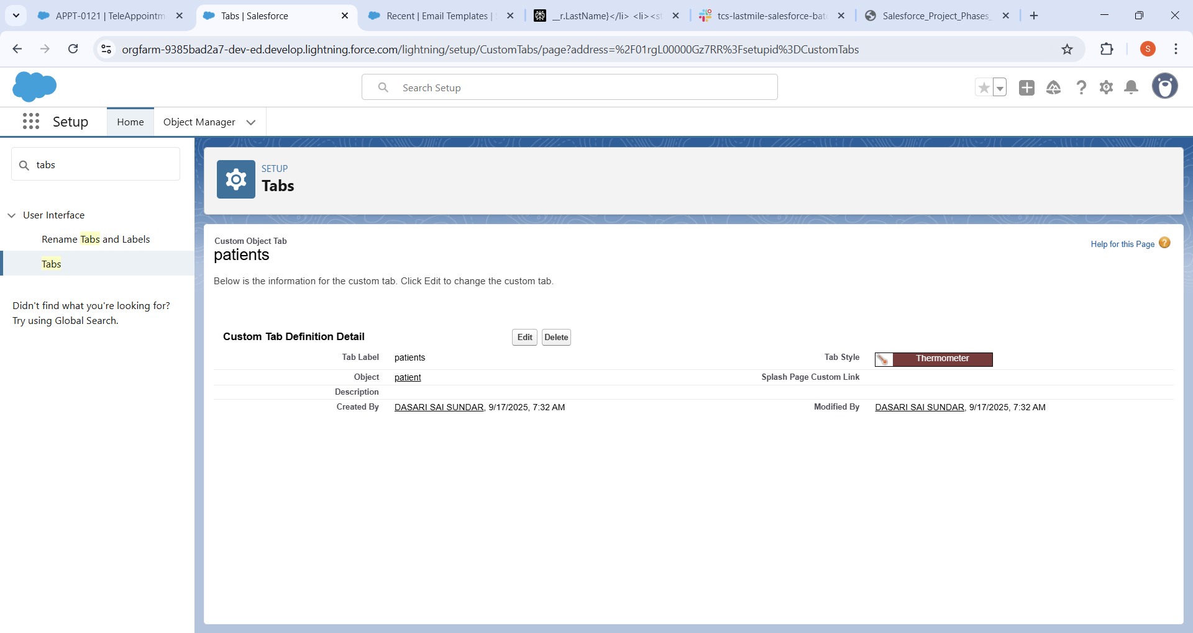

Doctor Tab Created:

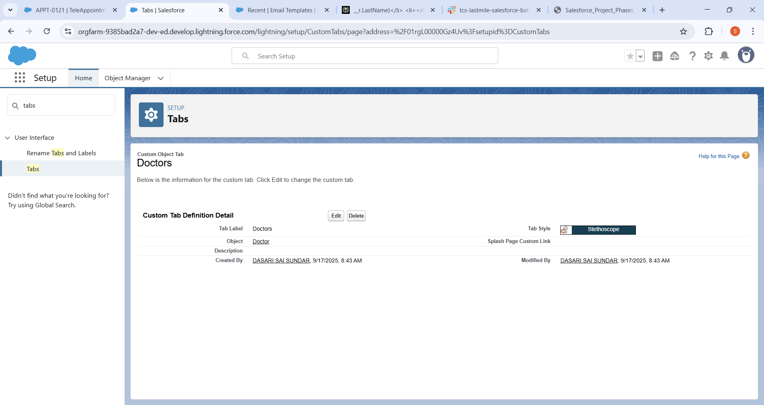

Prescription Tab created:

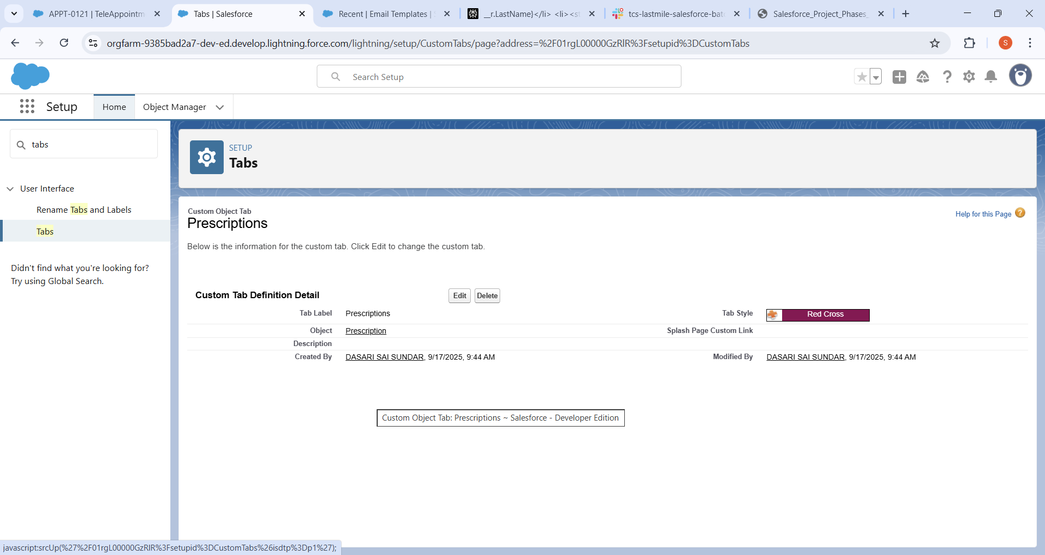

TeleAppointment Tab Created:

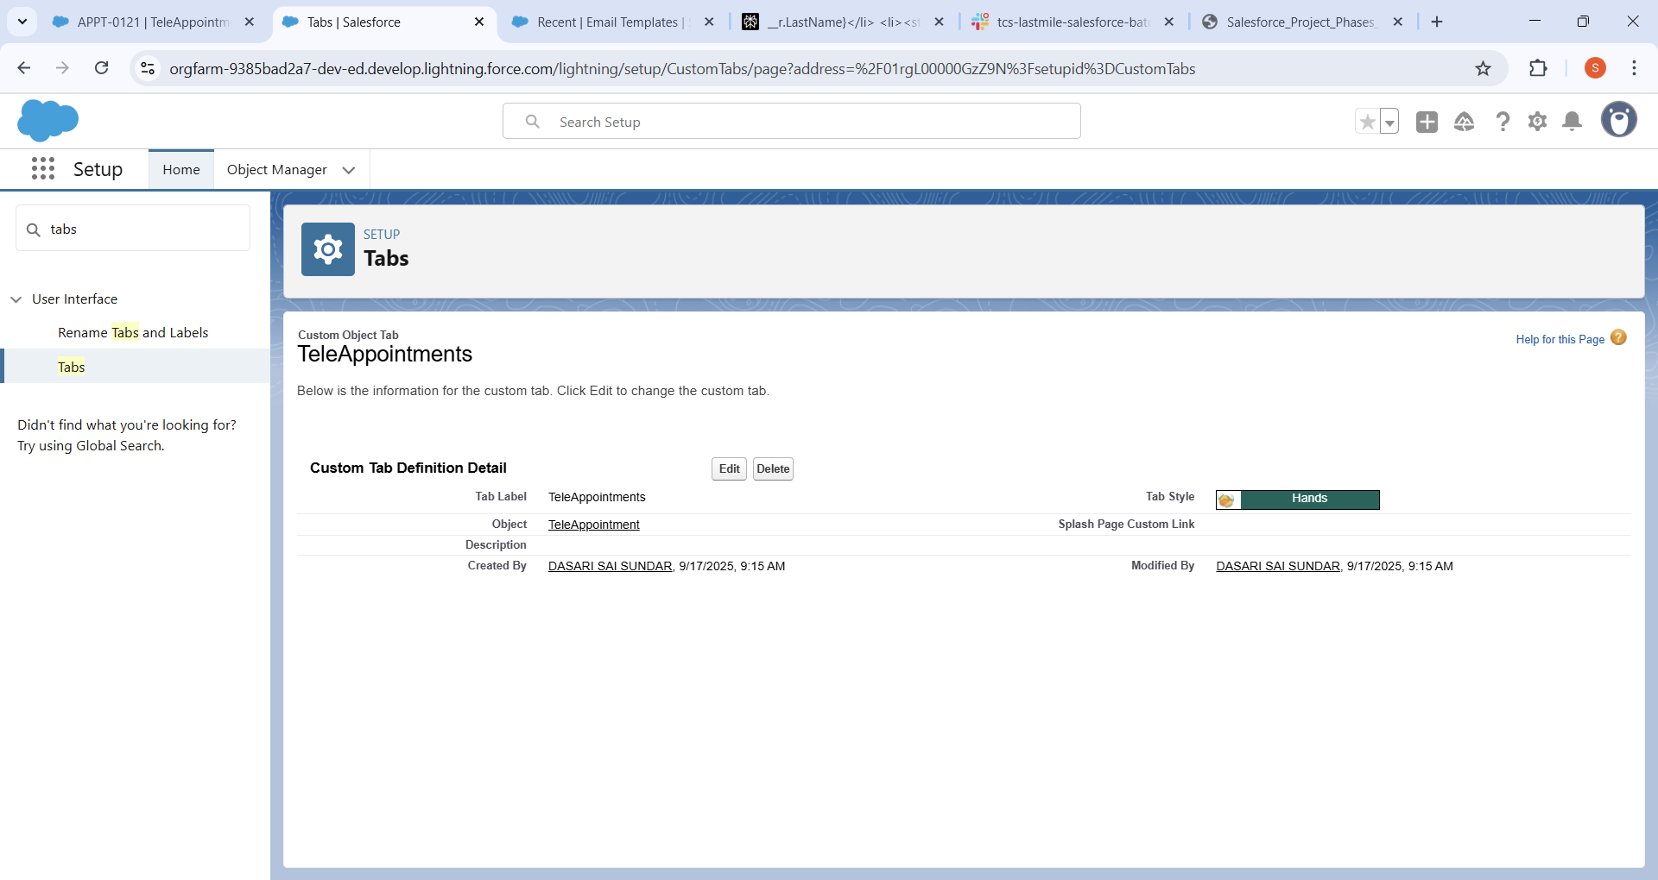

The created Tabs are Patients, Doctors, TeleAppointment, Prescriptions for easy navigation within Salesforce. These tabs help users quickly access relevant records and features in the telemedicine platform with distinct icons for better visual identification. This setup ensures streamlined workflow and improved user experience.

**4.Lightning Web Component:**

Different lwc are created like appointment booking , Doctor Schedule, Patient history, Prescription Viewer.

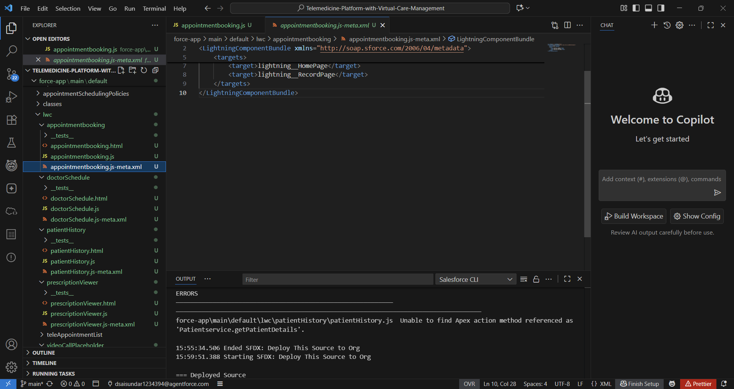

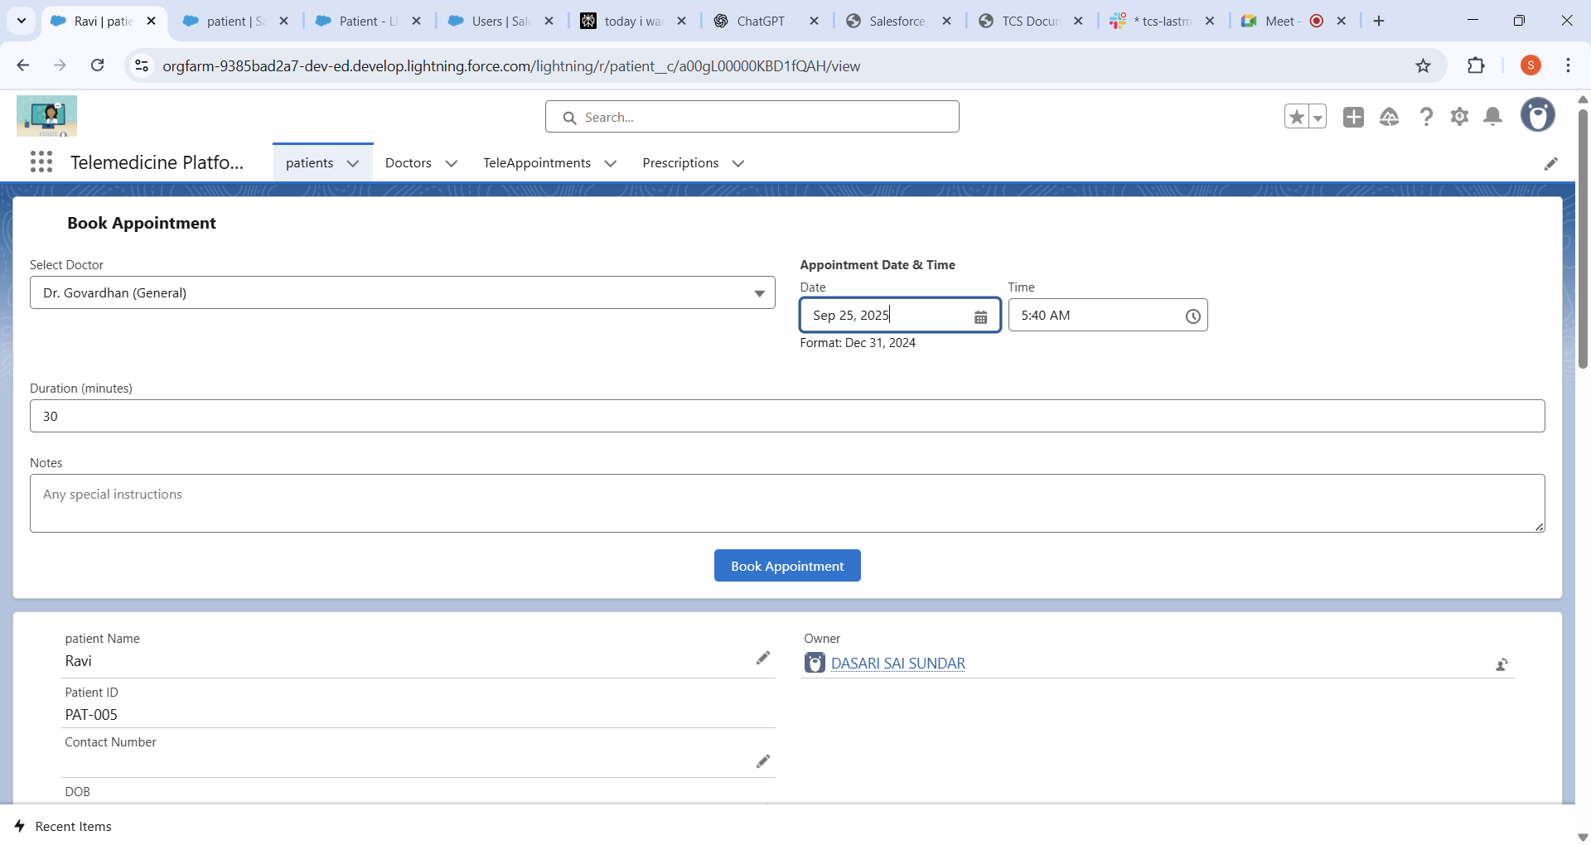

This is creating the Book Appointment to the Patient accordingly.

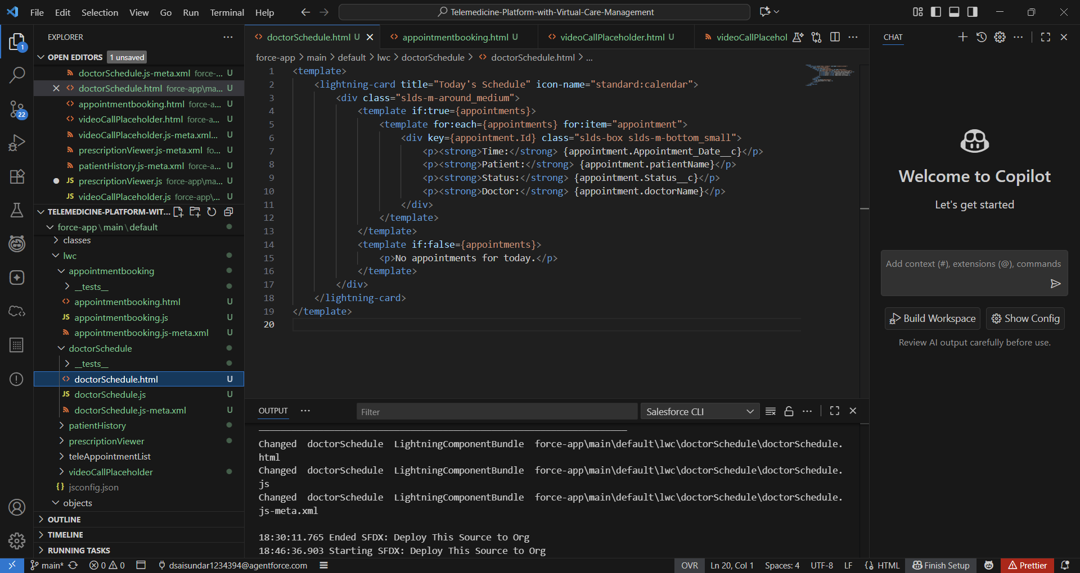

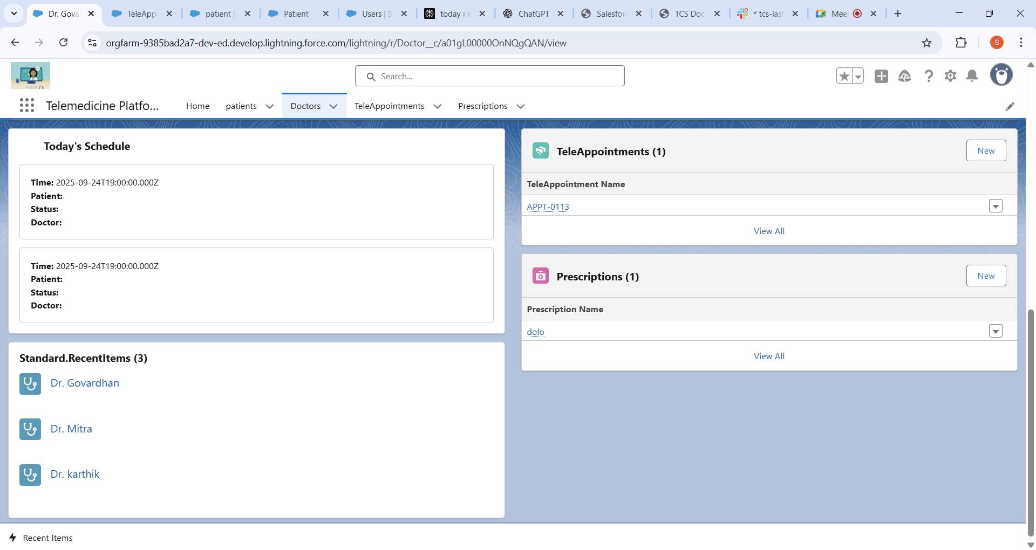

Doctor Schedule is created as he can see how many schedules are there that day.

Created the PatientHistory LWC:

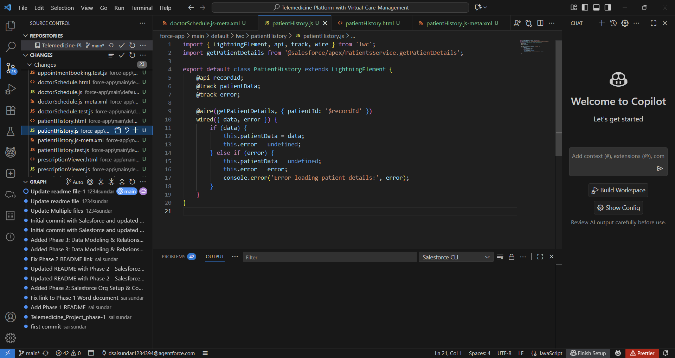

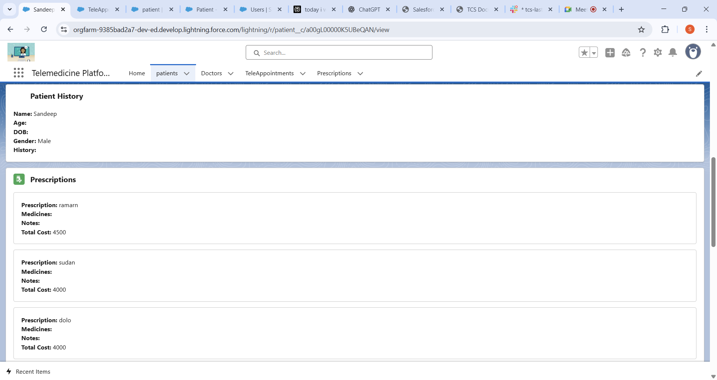

In the above image we can see the patient is displaying

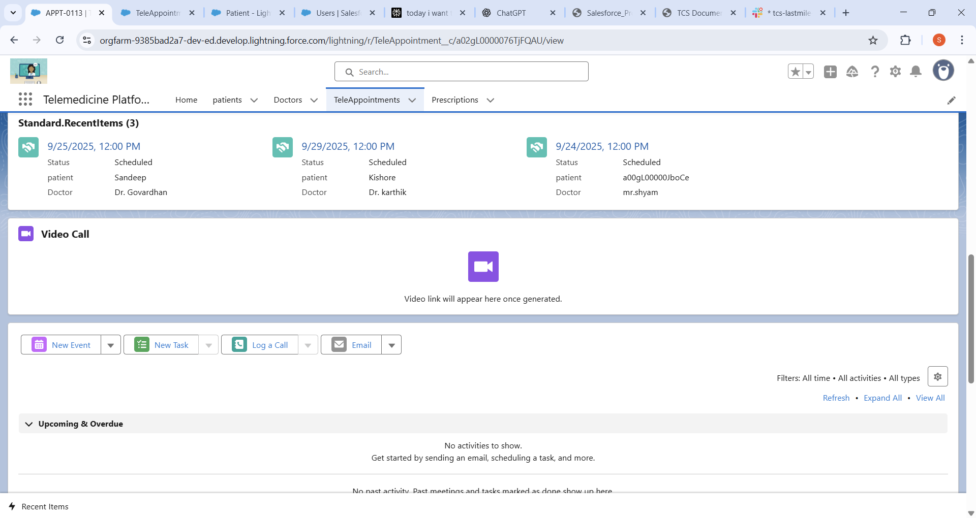

Google meet Video Call lwc is created as we go to phase the 7 we can do Background work of link generation

This is the patient Object Record Page layout with the custom Lwc’s like the patient history and the prescription.

Lightning Web Components (LWCs) like appointment booking, doctor schedule, patient history, and prescription viewer enable streamlined telemedicine workflows by providing interactive and real-time data access for patients and doctors. Integrated features such as Google Meet video call support enhance virtual consultations, while the custom LWCs deployed on patient record pages deliver a unified, efficient healthcare management interface.

**5.lightning Record Page:**

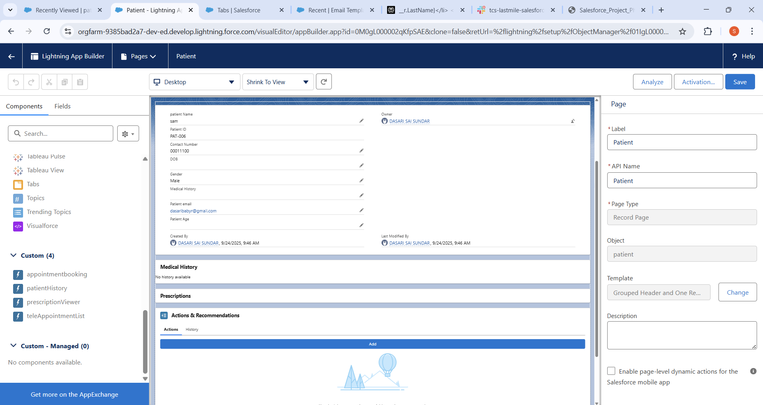

From the above we can see the Appopintbooking ,PatientHistory, Prescription Viewer and the Placevideocall custom lightning apps.We just drag them into the lightning page.

**6.Navigation Buttons:**

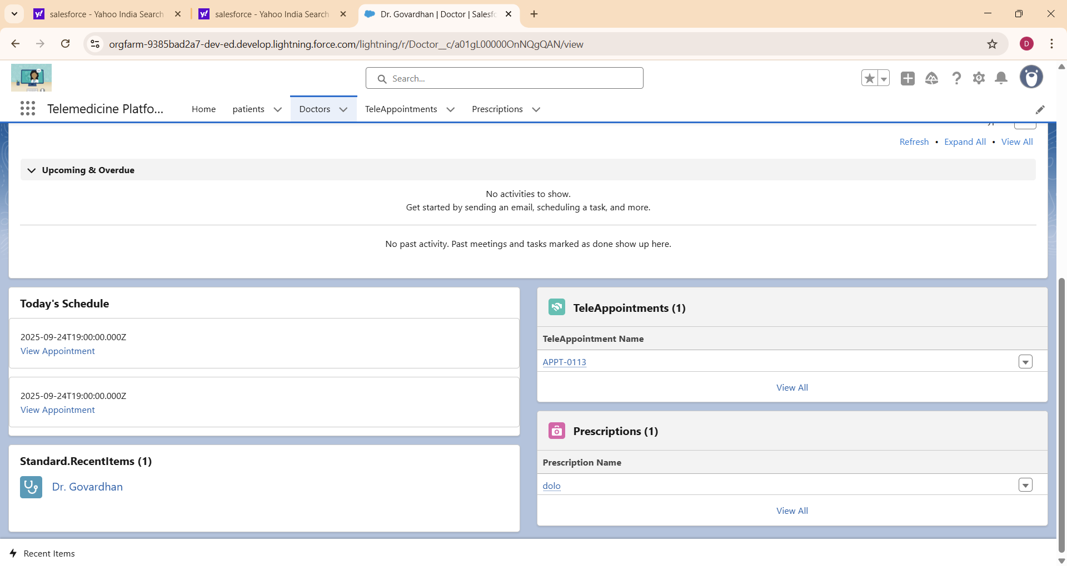

By clicking the view appointment can directly takes Doctor to the Teleappointment.

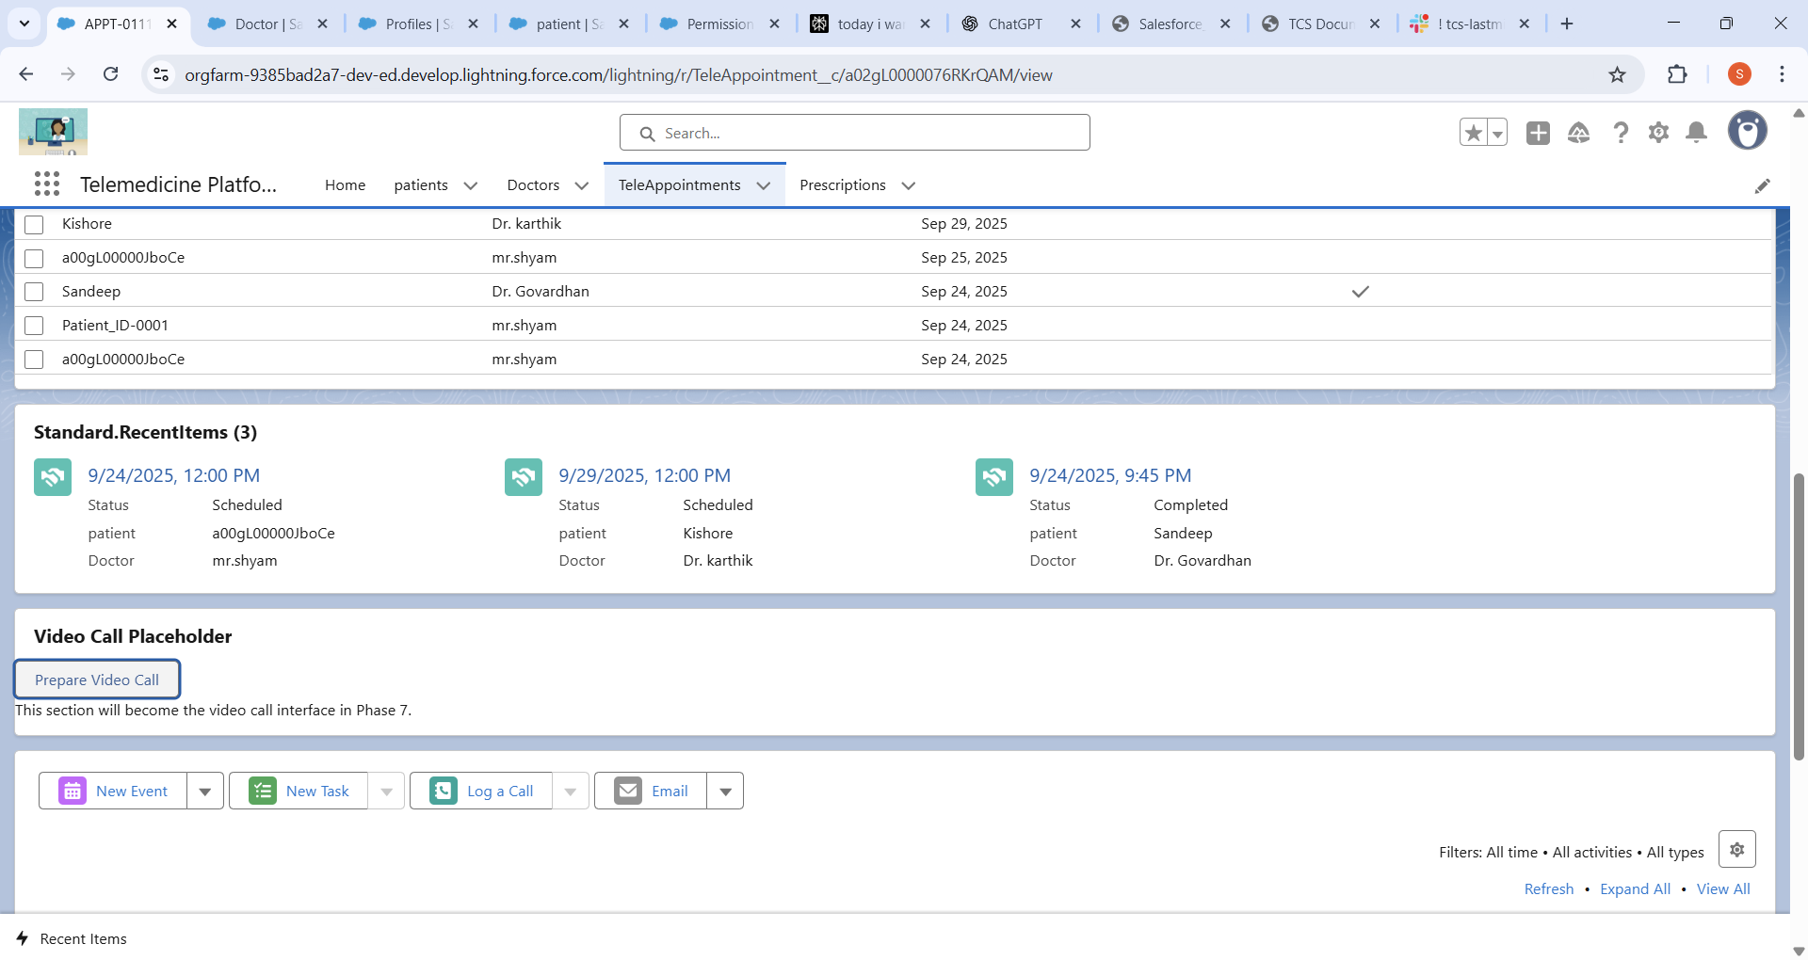

By clicking the Prepare video we can directly goes to the google meet with the patient

Navigation buttons in the telemedicine platform enhance usability by allowing doctors to instantly access detailed appointment information and initiate video consultations via Google Meet with a single click. This seamless integration improves workflow efficiency and ensures timely interactions between doctors and patients.